**AUDIENCE INFORMATION GUIDE**

**August 24th and 25th 2024**

**www.fuddlefest.ie**

We’re looking forward to welcoming you to FuddleFest this weekend! Below is some general information about the festival and facilities available.

**Entry Location and Festival Times:**

The festival address is Fuddletown, Killinick, Co. Wexford, Y35AC97.

Link to google maps: <https://goo.gl/maps/gyYjUvtexiu13CUF7>

The gates for the festival will open at 13:00 on Saturday 24th August. Please don't arrive before this time, as entry won't be permitted until the gates are opened. We will have a ticket booth set up at the entrance to the venue where you can check in with our ticket booth attendants who will scan the QR code on your ticket (this can be accessed on your mobile device or printed out on paper). You will get a wristband which will allow attendance for the duration of the ticket. You must wear the wristband at all times while at FuddleFest, as security checks will be in place throughout the weekend, so make sure you don't remove the wristband as security may remove you! Each QR code will only work once, so if you have bought tickets for a group of people who are not travelling/arriving together, please ensure you have distributed the tickets to your guests to make sure they can enter using their own ticket with unique QR code, (and if you could also share this email with them that would be great!).

If you have purchased a Student ticket, you must present a valid student ID at the ticket booth for entry. If you have a children’s ticket for Under 12s, you must be accompanied by an adult parent/guardian. The FULL WEEKEND ticket is the only ticket type that is valid for camping overnight at FuddleFest. If you have purchased a single day ticket for either the Saturday or the Sunday, that only entitles you to entry on the specified day.

The opening concert of the festival is on Saturday 24th August at 14:00 and the gates will be open for the audience to come and set up camp from 13:00. The final performance on Saturday will finish at around 02:00 in the night. The first performance on Sunday 25th will be at 11:00 and the closing concert is at 19:00, so the festival shall wrap up by about 20:00. We hope to have the venue vacated by 22:00 on the Sunday, and please make sure to take all of your belongings with you.

**Ticket Booth opening times:**

Saturday from 13:00 – 23:00

Sunday from 09:00 – 18:00

**Venue opening times:**

Saturday from 13:00 – 02:00

Sunday from 09:00 – 20:00.

Wristband holders are free to come and go from the venue, you do not have to camp or stay throughout! Just make sure to keep your wristband intact as they cannot be reapplied once tampered with, and a broken wristband won't be eligible for re-entry.

**Schedule of performances:**

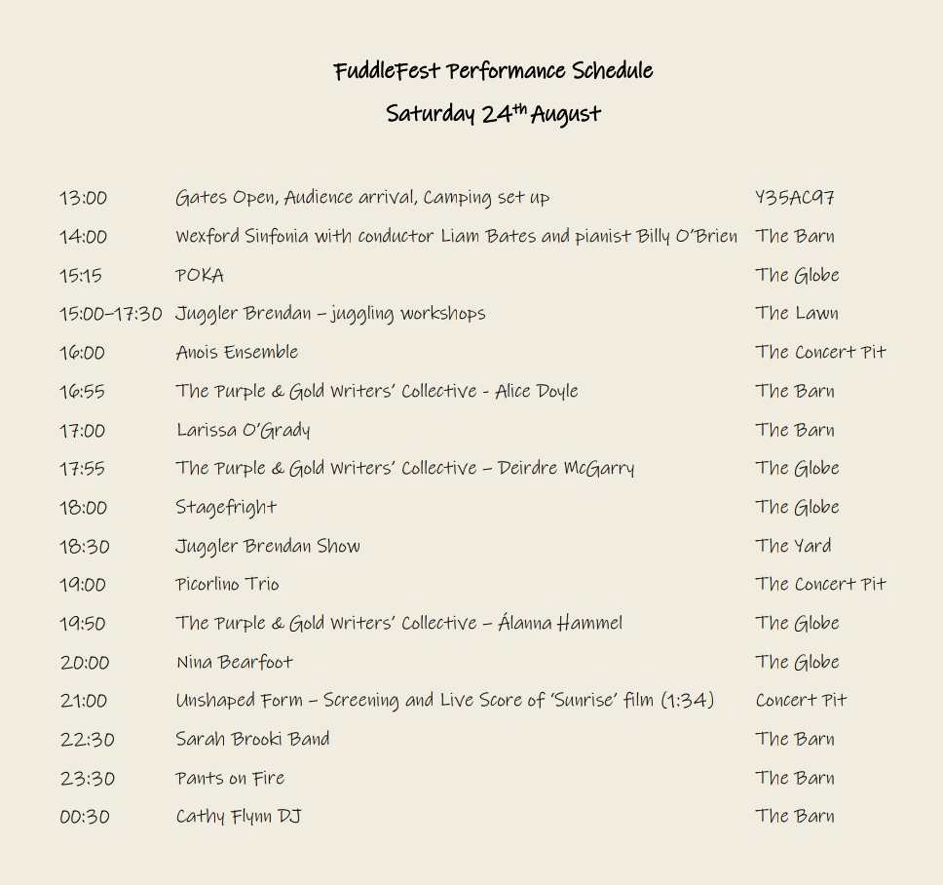

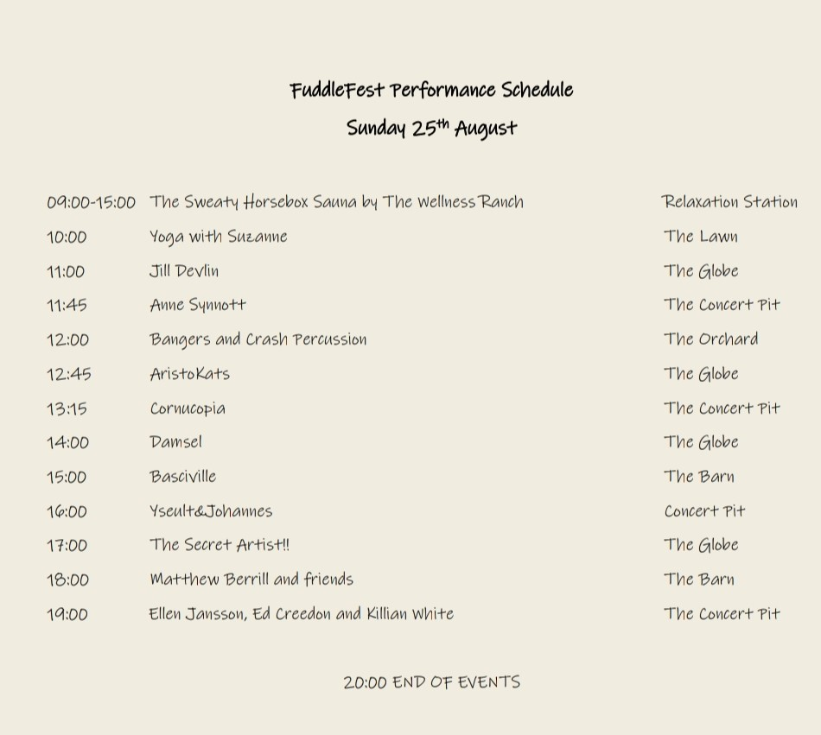

**How to get here:**

If you are travelling by car we will have a large car parking field. The car park entrance is all the way down the laneway, past the ticket booth and campsite, and will be signposted. Please have your tickets ready for inspection upon arrival, as the ticket attendants can check your tickets through the car window and send you on to park then. The eircode - Y35AC97 will bring you right here and the car parking attendants will direct you where to park. This car park is a 2-3 minute walk from the venue so if you have any accessibility/disability requirements just inform the ticket booth attendant and they can direct you closer to the main yard to be dropped off, or to park if you have a disability parking disc.

The Caravan and Campervan site is in the same field as the car park, with spaces allocated upon arrival. This will also be clearly signposted. If arriving in a caravan/campervan you will also drive past the ticket booth to enter the site, so please have your ticket ready to show to the ticket booth attendants.

Upon departure from the car park, if your vehicle gets stuck or if you're having any issues please contact the parking attendants and they will organise a tow if needed.

If taking public transport from Dublin we would recommend the train from Connolly – Wexford O’Hanrahan station: https://www.irishrail.ie/en-ie/ or taking Wexford Bus to Redmond Square: https://www.wexfordbus.com/. From Wexford Town to Fuddletown you can take the 390 or 381 bus to Murrintown Village which is a 45 minute walk from Fuddletown. It is a 40 minute cycle from Wexford Town to Fuddletown and we will have allocated space for bicycles if you wish to travel by bike.

**Facilities**:

There will be overnight camping in our Tent Campsite and Campervan/Caravan Site which will be available to audience members on the night of Saturday 24th August. There is no overnight camping on either the Friday 23th or Sunday 26th. The campsite will be open from 13:00 on Saturday 24th August to set up tents – we highly recommend setting up your tent during daylight hours as it can be quite the task in darkness!

There will be portaloo toilets at the venue, in the Yard and the Car Park, but there are no showers available. Check out our venue map below (drawn by Hugh Murray) for a general idea of locations of the stages.

**Food and Drink:**

FuddleFest will have the following food and drink options for purchase:

Pot Belly Café:

https://instagram.com/potbellycafe?igshid=MzRlODBiNWFlZA==

<https://goodeats.io/potbelly>

Sundae Best Ice Cream:

https://instagram.com/sundaebestwexford?igshid=MzRlODBiNWFlZA==

Please bring your credit or debit card and/or cash with you. Vendors will accept card/contactless and cash payments. There won’t be an ATM on site –the closest ATM and shop is the Londis in Piercestown Village and that closes at 21:30.

You’re welcome to bring your own food and drinks to the festival. FuddleFest has a BYOB (bring your own beverages) policy as there won’t be any alcohol for sale at the event. Soft drinks, hot drinks and signature drinks will be for sale from our vendors. As there is only one food van and one coffee van at the festival, we would also encourage audience members to bring their own snacks. If you have specific dietary requirements not available on the menu of the Pot Belly Café we would recommend bringing your own food along, as the closest shop is 8km away from Fuddletown. There will be a BBQ set up for the festival – if you wish to use it bring your own charcoals and food along to use that. We will have drinking water taps around the venue if you want to bring a bottle to refill and stay hydrated!

**Extra Activities at FuddleFest:**

Juggler Brendan is back this year at FuddleFest on Saturday 24th to wow us all with a spectacular new show at 18:30, but before that he will host juggling workshops suitable for all ages on The Lawn, so catch him between 15:00-17:30 and see if you can learn a new skill!

The Sweaty Horsebox woodfired sauna by The Wellness Ranch will be operating on Sunday 25th August from 09:00-15:00, with ice baths to chill in and a beautiful bell tent to relax in afterwards at our Relaxation Station. Message The Wellness Ranch on Instagram to book a 30 minute sauna slot to guarantee your spot, or text Conor at 0892123508. It will also be possible to sign up in person during the festival if there are any slots left available! The 30 minute sauna session will cost €10 per person and can be paid in cash or via revolut on the day. Don't forget to bring your own togs and towels along also. Personal belongings can be safely stored in The Wellness Ranch's van during your sauna slot.

On Sunday at FuddleFest, we are delighted to host a morning yoga session hosted by Suzanne Brennan of Ashtanga Yoga Shala Dublin. This is free to attend, just make sure to bring your own yoga mat along if you would like to join in and stretch out any creaks formed from sleeping in a tent and be at The Lawn at 10:00!

**Other info:**

Please keep the Irish weather in mind when dressing for FuddleFest – don’t forget to bring your wellies/waterproof boots, raincoats, umbrellas, warm clothes, suncream, sunglasses and hats – this event is largely outdoors and you can never be too sure what to expect, even in the Sunny South-East! We're hoping the hurricane will be long gone by Saturday!!

If you are camping overnight we recommend bringing a power bank to charge your mobile devices.

Dogs/Pets are welcome to attend the festival with their owners provided they are kept on a leash throughout the festival. We have ducks on the marlhole pond at Fuddletown and cannot risk any accidents with dogs near the marlhole We would ask owners to make sure to pick up any dog litter and to be mindful of other audience members interacting with your animal.

Ticket refund/exchange policy: FuddleFest 2024 tickets can no longer be exchanged or refunded. If you cannot attend the festival, it is possible to sell on your ticket by sending the buyer the QR code and ticket for their entry.

Please be mindful of the venue while attending the festival and do your best to put all of your waste in the bins provided. Bins will be labelled for general waste, paper/cardboard/plastic recycling, the can/bottle recycling scheme and glass bottles, so please help us to dispose of the festival waste correctly.

Volunteers of FuddleFest will be wearing high-vis vests during the event, if you have any questions while at the festival these people can direct you!

If you have any questions that are not addressed on this guide, please don’t hesitate to get in touch!

Contact: [fuddlefest@gmail.com](mailto:fuddlefest@gmail.com)

The map schedule and artist line-up is available at our social media pages of Instagram and Facebook.

Funded through Wexford County

Councils Arts Office – Small Arts

Festival Grant Scheme 2024